**Assignment Date : 22-09-2022**

**Name : SRAVANI T**

**Reg No : 111519106153**

**Maximum Marks : 2Marks**

**Question**

Build a python code by assumming temperature and humidity values using random function .And write a condition to continuously buzz an alarm in case of high temperature.

Program:

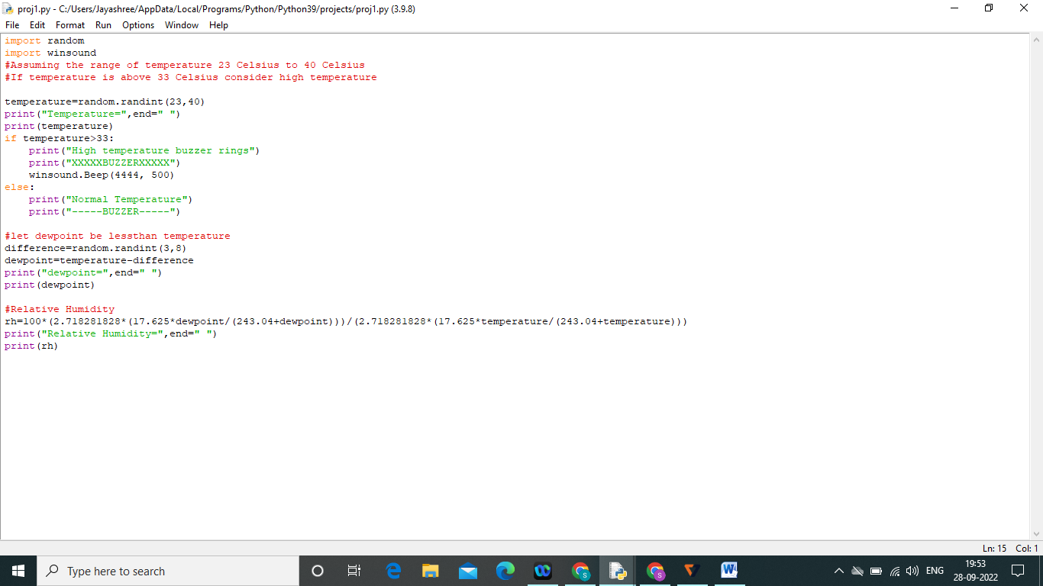

Output:

